**Front-End Web Development-A**

**Nama-Nama Anggota kelompok :**

1. **Francesco Figo Repu**
2. **Andriano Tielung**
3. **Novanca Tasya Tulende**
4. **Joshua Dadung**

* **Exercise #1**

**Table Dynamically (Insert,update & Delete Rows)**

**Code HTML :**

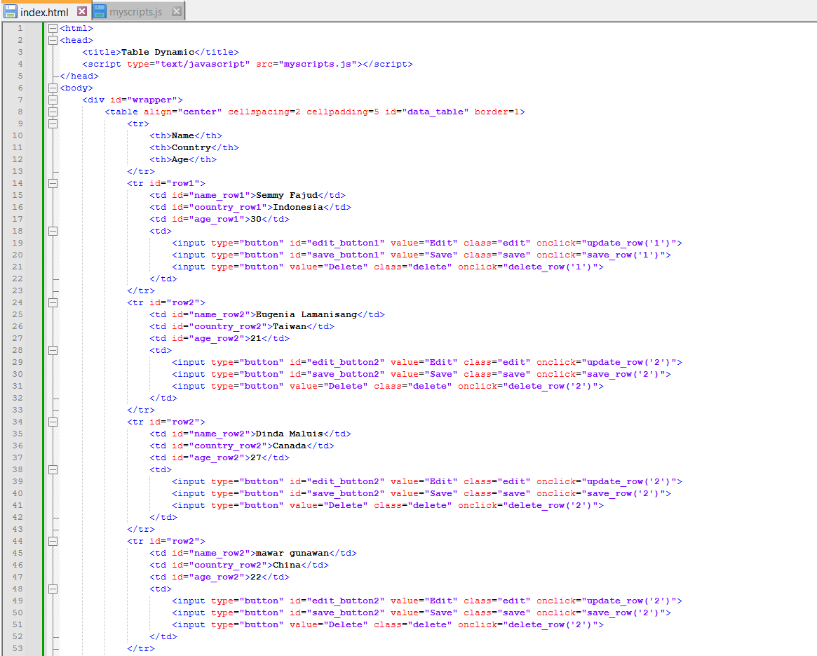

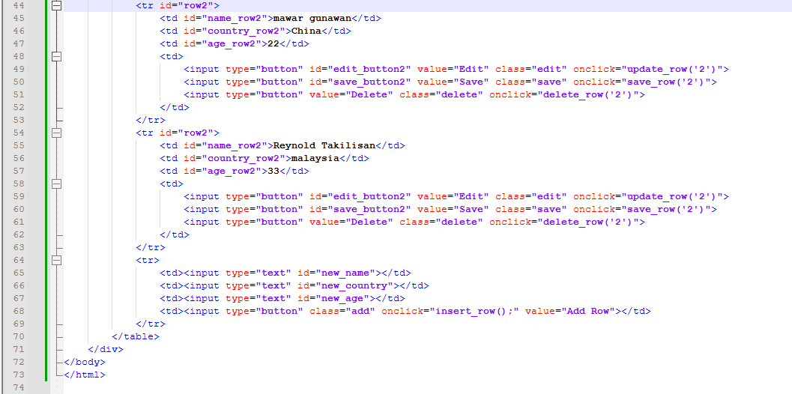

**Code JS :**

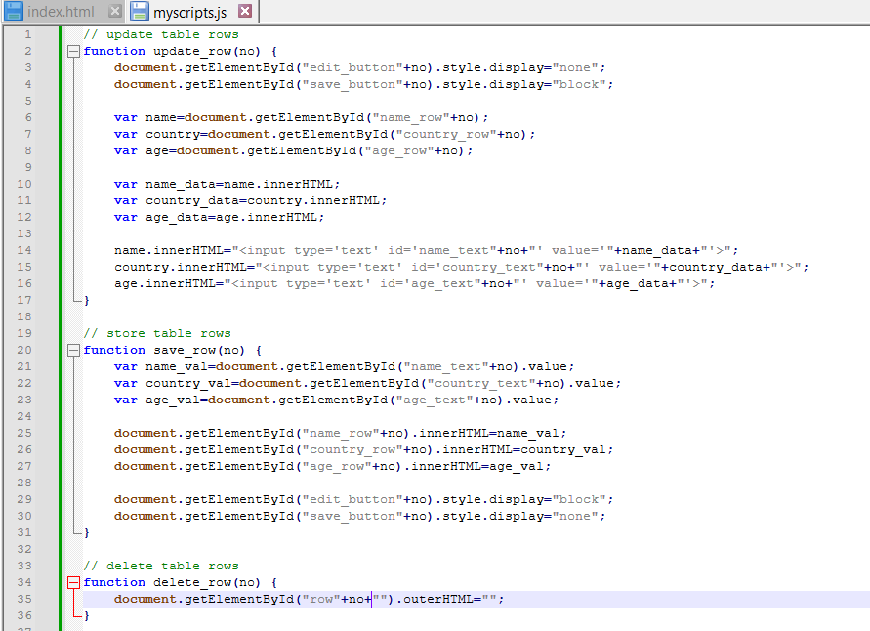

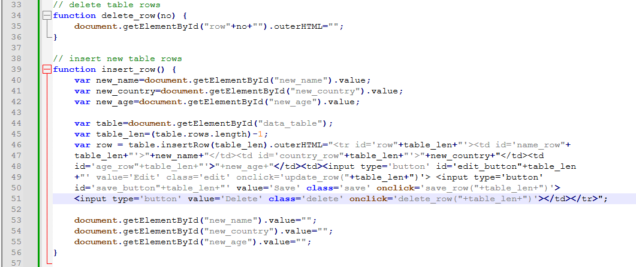

**Output:**

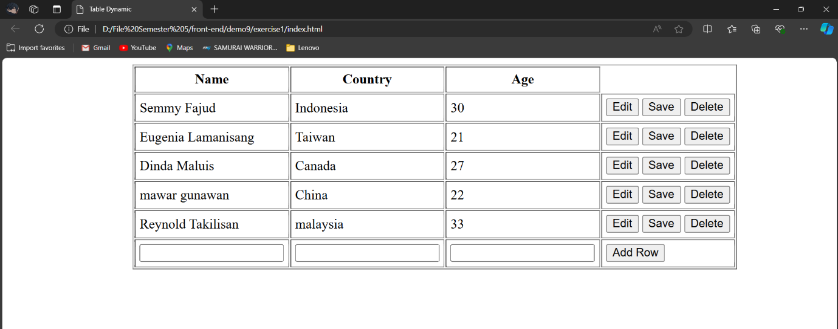

* **Exercise 2**

**Create Digital Clock in JavaScript**

**Code HTML:**

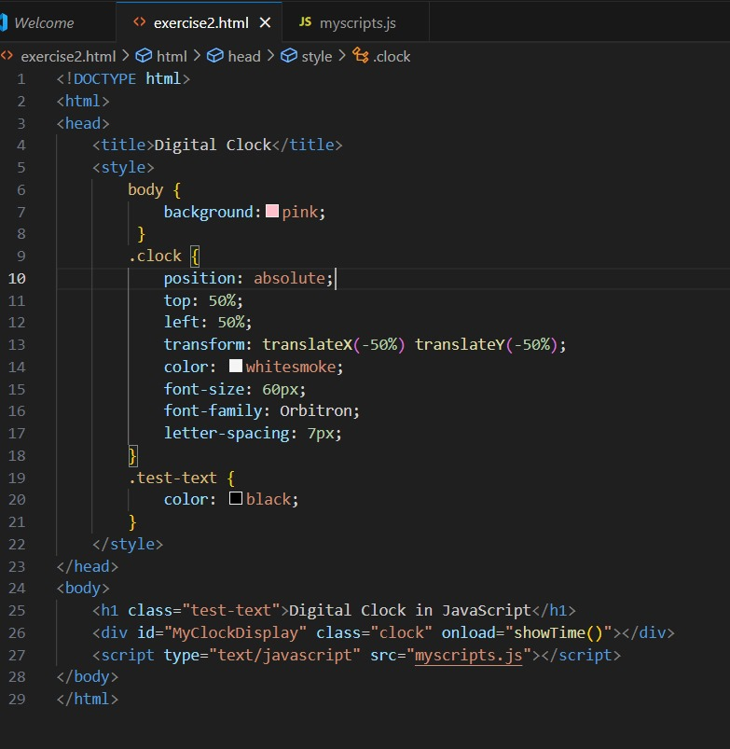

**Code JS :**

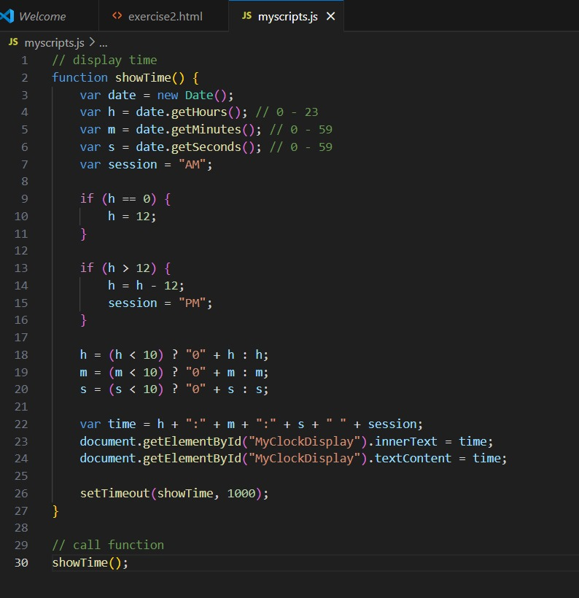

**Output:**

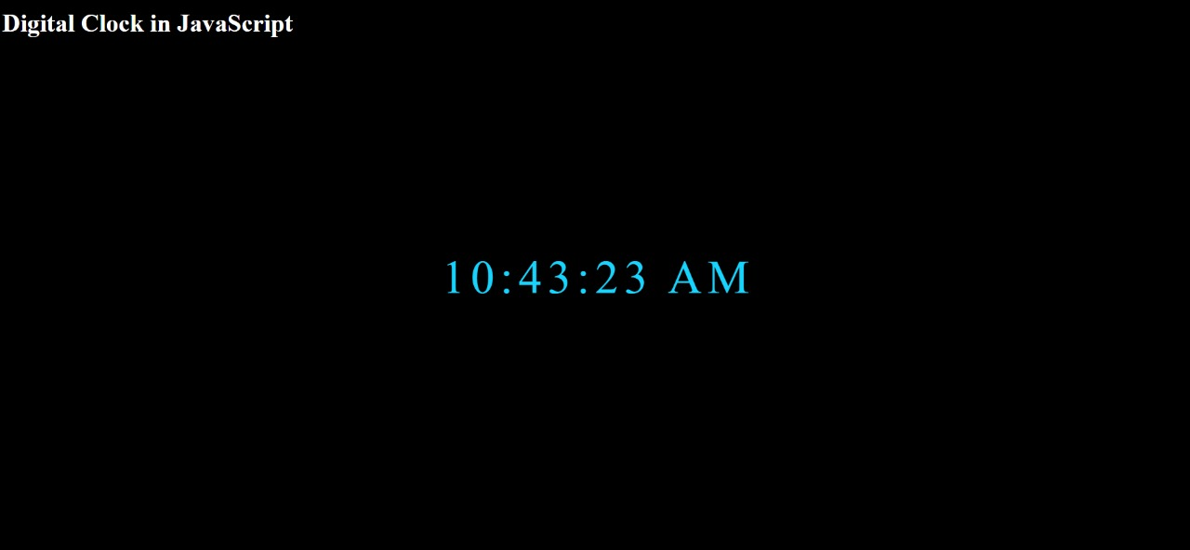

* **EXERCISE 1 GRAPHICS**

**Code #1 (Line Graph)**

**Index.html**

**Myscripts.js**

**Output**

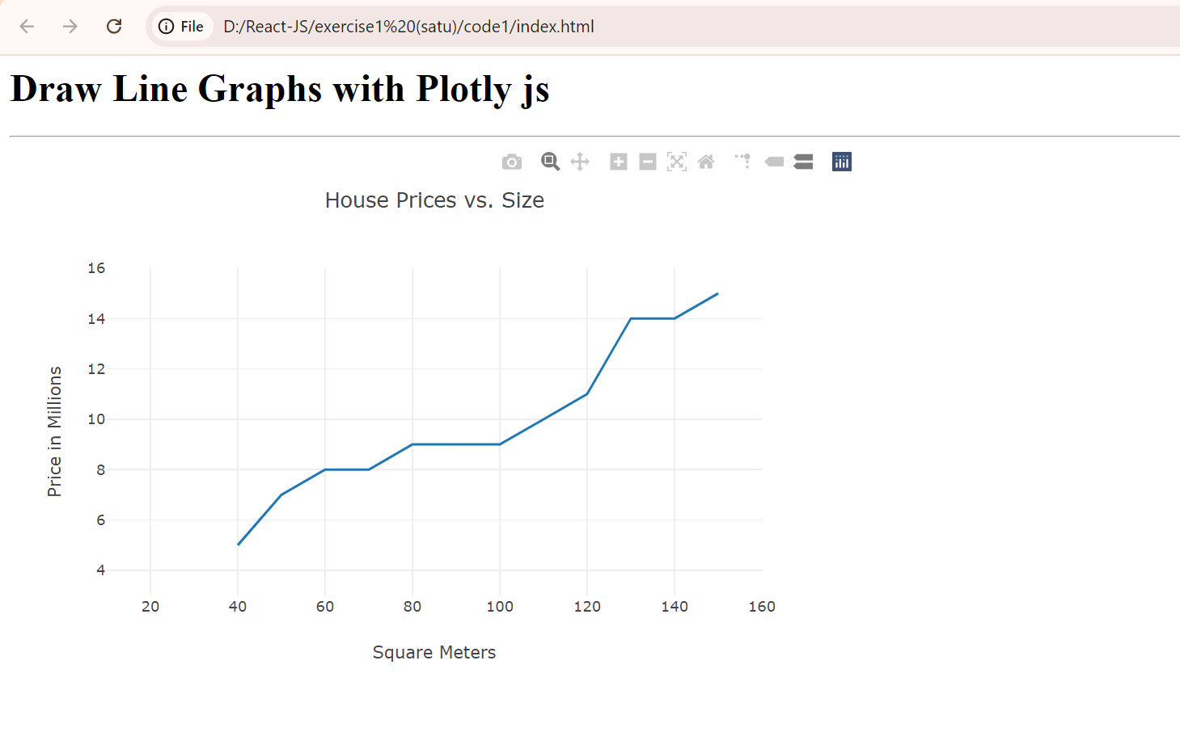

**Code #2 (Bar Charts)**

**Index.html**

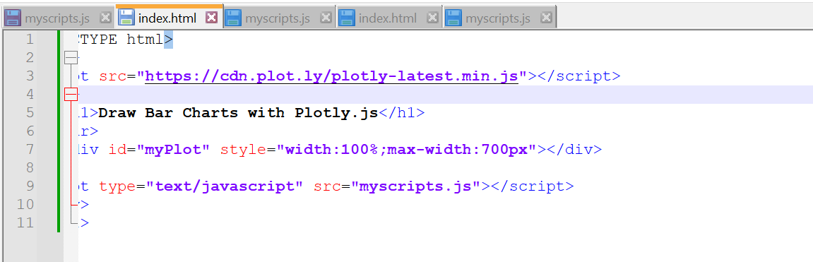

**Myscripts.js**

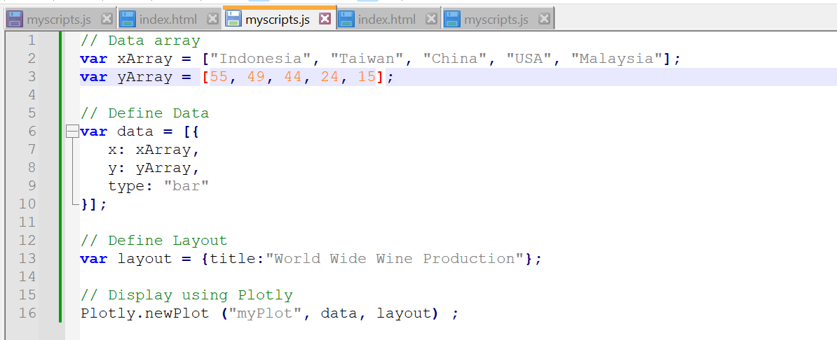

**Output**

**Code #3 (Donut Charts)**

**Index.html**

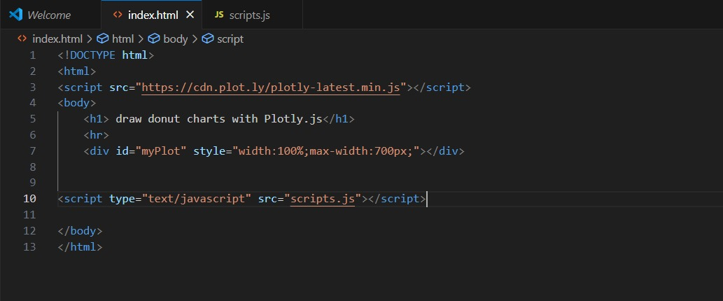

**Scripts.js**

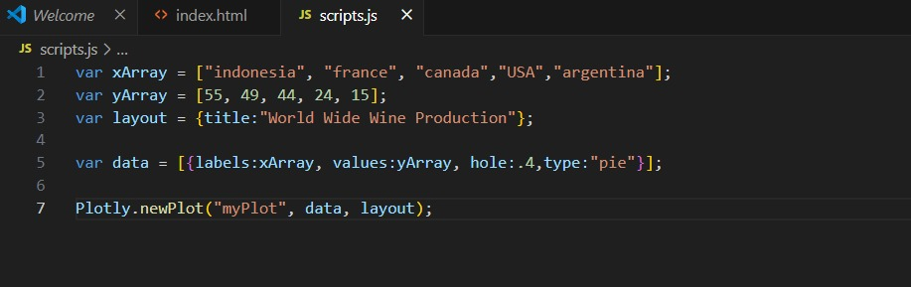

**Output**

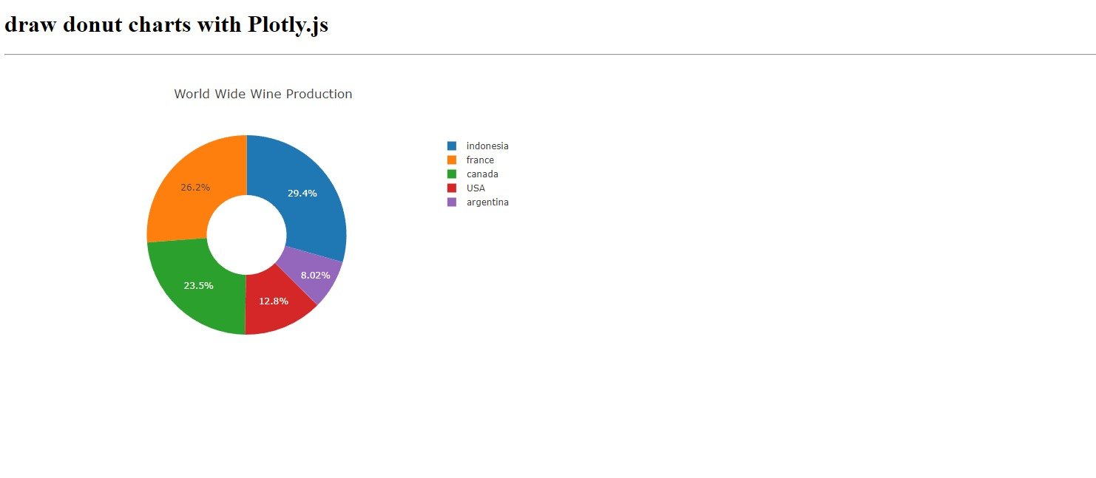

**EXERCISE 2**

**DRAW DYNAMIC DONUT CHARTS**

**Code HTML:**

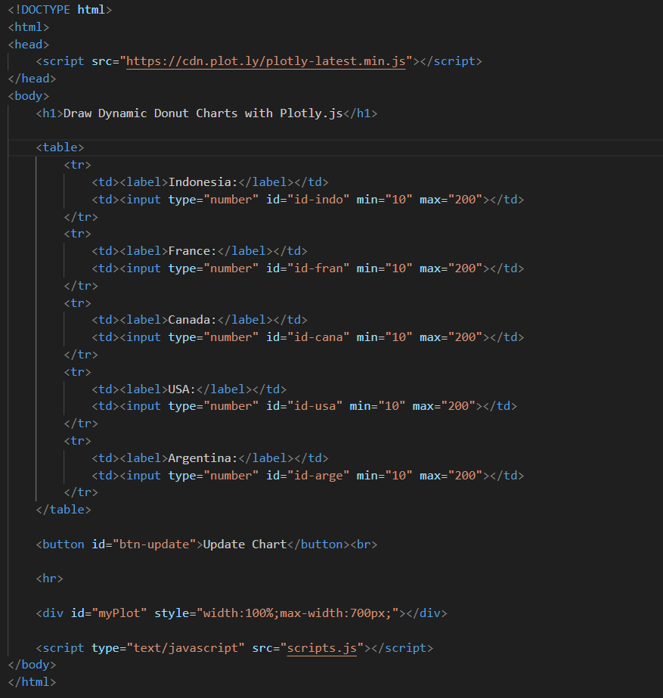

**Code JS:**

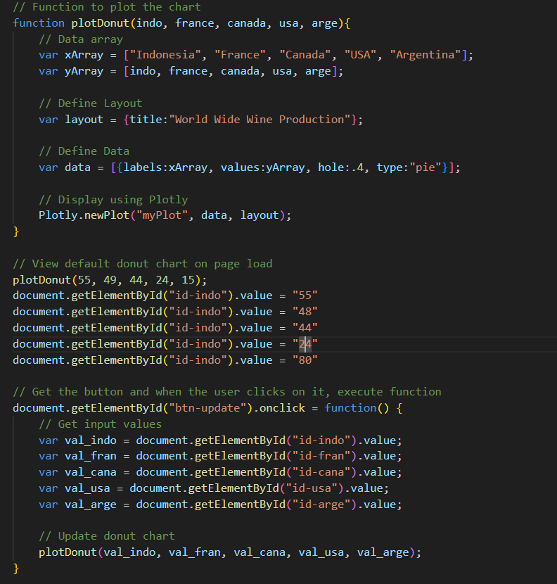

**Output :**

